**Service 1: Deep Insert**

Steps:

1. Create one project in segw : zdemo_day4

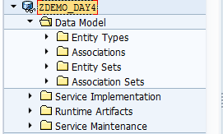

1. Import two structures to create entity types: Student and Reportcard

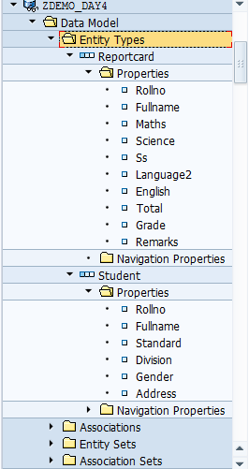

1. Create entity sets: Studentset and Reportcardset

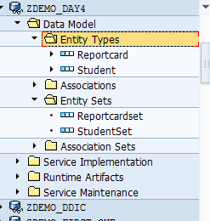

1. Create Association from Student entity to Reportcard entity.



1. Generate runtime classes
2. Go to Implementation of class -ZCL_ZDEMO_DAY4_DPC_EXT
3. Redefine method : CREATE_DEEP_ENTITY under the folder /IWBEP/IF_MGW_APPL_SRV_RUNTIME
4. Copy and paste the below code



1. Save and Activate
2. Go to transaction : /iwfnd/maint_service
3. Pass request payload ( The response for get_expanded_entityset), request URL
4. HTTP Method – POST, execute
5. 201 Created means successful creation

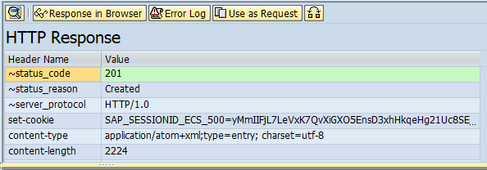

**Service 2: Function Import**

<https://help.sap.com/saphelp_nw74/helpdata/en/c5/dc22512c312314e10000000a44176d/content.htm>

We will consider material validation example here.

Create a project in SEGW

Create an entity type name material with the following properties

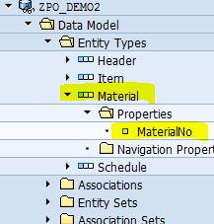

We only need one property i.e. material number here as we will send back only material number if it is valid.

Right click on function imports->Create -> Enter the following properties



Create an import parameter for the function import:

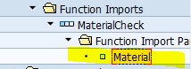

Redefine the below method:

/IWBEP/IF_MGW_APPL_SRV_RUNTIME~EXECUTE_ACTION

And paste the below code

IF iv_action_name = 'MaterialCheck'.  
  
    DATA : ls_parameter  TYPE /iwbep/s_mgw_name_value_pair,  
           lv_matnr TYPE matnr,  
           ls_entity TYPE zcl_zpo_demo2_mpc_ext=>ts_material,  
         lv_material TYPE matnr,  
         ls_header TYPE ihttpnvp.  
  
    READ TABLE it_parameter INTO ls_parameter WITH KEY name = 'Material'.  
  
    IF sy-subrc = 0.  
  
      lv_matnr = ls_parameter-value.  
  
      CALL FUNCTION 'CONVERSION_EXIT_ALPHA_INPUT'  
        EXPORTING  
          input  = lv_matnr  
        IMPORTING  
          output = lv_matnr.  
  
      SELECT SINGLE matnr  
                    FROM mara  
                    INTO lv_material  
                    WHERE matnr = lv_matnr.  
  
      IF sy-subrc = 0.  
        ls_entity-materialno = lv_material.  
  
        copy_data_to_ref(  
          EXPORTING  
            is_data = ls_entity  
          CHANGING  
            cr_data = er_data  
        ).  
      ELSE.  
* This piece of code is to pass messages in header  
        ls_header-name = 'Status'.  
        ls_header-value = 'E'.  
        set_header( is_header = ls_header ).  
  
        ls_header-name = 'Message'.  
        ls_header-value = 'Material not found'.  
        set_header( is_header = ls_header ).  
      ENDIF.  
    ENDIF.  
  
  ENDIF.

Test from GW client with the URI:

**URI:**

/sap/opu/odata/sap/ZPO_DEMO2_SRV/MaterialCheck?Material='986'

**URI:**

/sap/opu/odata/sap/ZPO_DEMO2_SRV/MaterialCheck?Material='654654'

Enter wrong Material number:

